# <MTG: The Database>

<Alexandria Piatt>

<Code Bagel>

Revision History

|  |  |  |
| --- | --- | --- |
| **Last User to make Changes** | **Date** | **Summary of Changes** |
|  |  |  |
|  |  |  |

Table of Contents

Vision Statement 4

Requirements 5

Step #1: Identify Categories of Users 5

Step #2: Create Actor-Goal List 5

Step #3: Identify User Stories 5

Product Backlog 6

Sprint #1 8

Coding Standards 9

# Vision Statement

Created by a Magic the Gathering collector and player, for the MTG enthusiast. MTG: The Database brings simplicity and elegance to cataloguing cards. The high powered search included will never leave the user looking for the perfect card to add to a deck. With a customizable category that allows the user to leave a note attached to a card, the user will never be left unsure on how categorize it. MTG: The Database transforms the ordinary user into an extraordinary Planeswalker.

# Requirements

***Actors:***

Card Collectors who want to electronically catalogue their collections.

***Actor Goal List:***

|  |  |
| --- | --- |
| **Actor** | **Goal** |
| Card Collector | Add / remove cards to/from their personal database |
|  | Search their DB by a variety of options (card title/mana cost/card type/card color/mana type/users personal note) |
|  | Build and save decks |
|  | Export deck to spreadsheet |
|  | Sort deck based on card type |
|  | Utilize the life counter in game matches |
|  | Deck analyzer (stretch goal) |
|  | Make generalized suggestions for deck (i.e. more creatures) |
|  | Simulate draws on created deck (stretch goal) |
|  |  |
|  |  |

*User Stories:*

1) As a card collector I want to be able to easily categorize my cards.

2) As a card collector I want to be able to search for my cards using multiple different search options.

3) As a card collector I want to be able to build and save multiple different decks that can be reviewed and exported.

4) As a card collector I want to be able to sort my deck.

5) As a card collector I want to be able to use an electronic life counter in my matches.

6) As a card collector I want to be able to analyze my deck to see if I need to add more of any card type.

7) As a card collector I want to be able to simulate my card draws to get an idea of how the deck would perform.

8) As a card collector I want to my database tool to be able to make deck suggestions based on my ratio of card types.

### Product Backlog

The collection of stories makes up your project’s product backlog:

| Story ID | Story | Story Points | Priority | Status |
| --- | --- | --- | --- | --- |
| 1 | See above | 15 | 1 | Complete |
| 2 | See above | 10 | 2 | Started but incomplete |
| 3 | See above | 4 | 3 | Not started |
| 4 | See above | 5 | 4 | Not started |
| 5 | See above | 2 | 5 | Not started |
| 6 | See above | 3 | 6 | Not started |
| 7 | See above | 5 | 7 | Not started |
| 8 | See above | 7 | 8 | Not started |

***Other requirements/ System requirements***

1. While entering in a card information, the user shall be able to leave fields incomplete.

2. When a new card is entered the system shall check to see if an exact title match already exists.

2a. If found, the system shall add the cards quantities rather than add another entry.

3. The system shall not allow incorrect information to be entered. (i.e. the system shall not accept any entry except an integer for quantity of card.)

4. The system shall confirm entered information with the user before committing to the database.

4a. If changes need to be made the system shall repopulate all of the already entered fields.

5. While searching for a card, the user shall be able to enter a partial title and the system shall return all matches of the partial title match.

6. The system shall allow the user to set the life counter to any integer < 200.

7. The system shall allow users to set an ideal deck ratio composition.

7a. The system shall have automatic presets if no deck ratio is set.

8. During deck simulation the system shall account for cards already drawn and remove them from the deck.

# Sprint #1

Sprint Backlog

|  |  |  |  |
| --- | --- | --- | --- |
| **Story ID** | **Story / Task** | **Estimated**  **Hours** | **Actual**  **Hours** |
| S0 | Prototype full UI | 1 |  |
| S1 | Design the add card feature UI | 2 |  |
| S1 | Create actual database table(s) | 6 |  |
| S1 | Add relations between the tables | 3 |  |
| S1 | Implement all fields needed for add card feature | 5 |  |
| S1 | Connect DB to UI | 2 |  |
| S1 | Code save button  if time have system check information with user  might need to save task for later sprint | 3 |  |
| S1 | Design front page of app with just add button  but ensure space for all other options | 1 |  |
|  |  |  |  |
|  |  |  |  |

## 

# Coding Standards

Will be added to as project continues:

Comments will be kept to a minimum and only used for wonky logic.

Sprint 1 Reflection

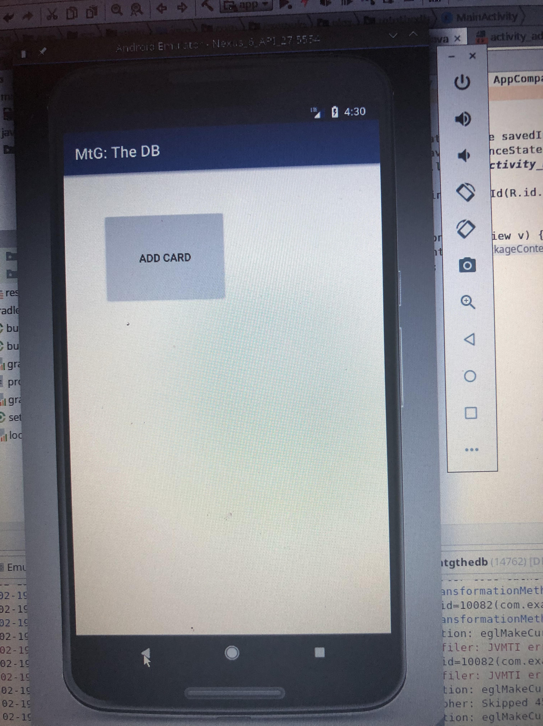**Added features:** Add Card Button to home screen

Implement Add Card Feature

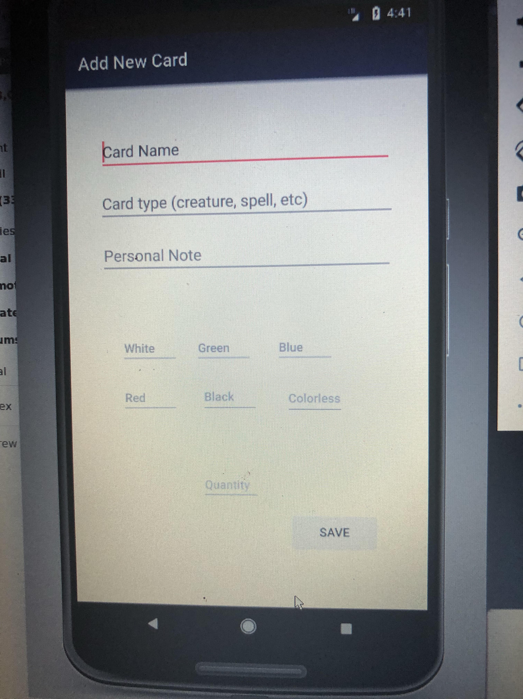

Show user input data on pushing save

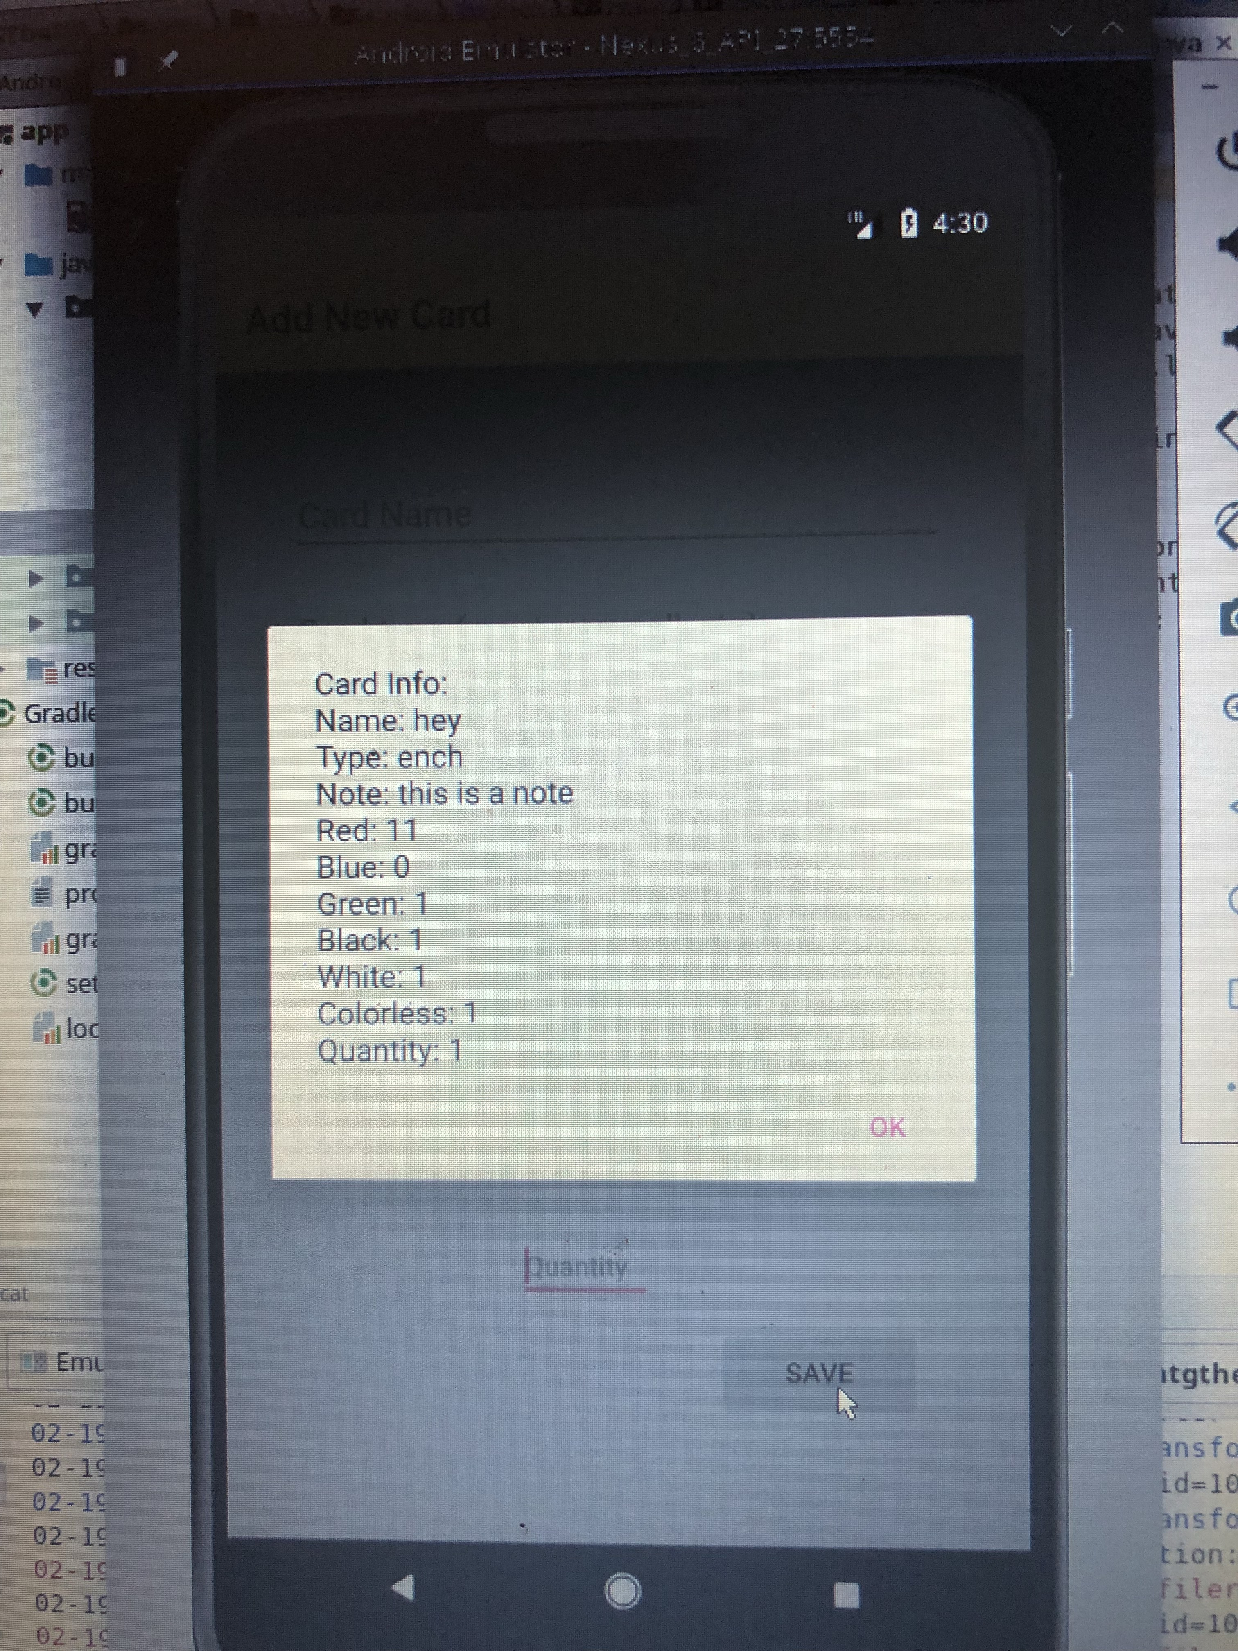

|  |  |  |  |
| --- | --- | --- | --- |
| **Story ID** | **Story / Task** | **Estimated**  **Hours** | **Actual**  **Hours** |
| S0 | Prototype full UI | 1 | 1 |
| S1 | Design the add card feature UI | 2 | 3 |
| S1 | Create actual database table(s) | 6 | 8 |
| S1 | Add relations between the tables | 3 | 0 |
| S1 | Implement all fields needed for add card feature | 5 | 3 |
| S1 | Connect DB to UI | 2 | 3 |
| S1 | Code save button  if time have system check information with user  might need to save task for later sprint | 3 | 4 |
| S1 | Design front page of app with just add button  but ensure space for all other options | 1 | 1 |
| Total |  |  | 23 |
|  |  |  |  |
|  |  |  |  |
|  |  |  |  |

Sprint review:

Currently only one table needed for functionality, so the need to create tables and add relationships was unnecessary. Otherwise, all tasks were completed. The system can add a card to the database. Currently it can be very slow and resource heavy. These issues will be addressed in next sprint.

Sprint Retrospective:

Officially, all goals were accomplished during this sprint. Every story included (that proved to be needed at this point) were included in the end of the sprint code. Comfort with XML files greatly improved between the beginning of the sprint and the end of it.

The most important improvement to make will be to research more first. Trial and error in the task of implementing a Room Database was very inefficient. Too much time was spent trying to figure out errors that could have been avoided with a bit more thorough research and planning. Moving forward I will focus more on having a full understanding of my task and my plan for executing it.

Sprint 2 Planning

|  |  |  |  |
| --- | --- | --- | --- |
| **Story ID** | **Story / Task** | **Estimated**  **Hours** | **Actual**  **Hours** |
| S1 | Improve speed of app when accessing Room | 5 |  |
| S1 | Create error message if Card lacks Name | 2 |  |
| S1 | If card already exists in DB at to the quantity | 4 |  |
| S1 | Add cancel if the user finds error in entered info | 2 |  |
| S2 | Design Search Page | 2 |  |
| S2 | Allow user to select a search by option | 4 |  |
| S1 | Use query to code delete button | 2 |  |
|  |  |  |  |
|  |  |  |  |
|  |  |  |  |

Sprint 2 Reflection

**Added Features:**

Enhancements to the add card feature:

*Check if card with same name exists in database: if it does update the quanti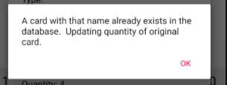ty.*

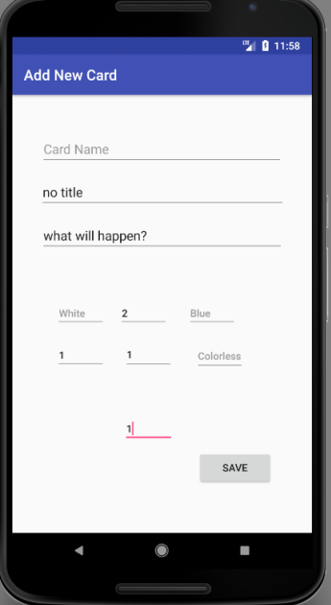

*Create error message if user tries to add a card without a Name. Preserve all other entered information and let user update the name and resubmit.*

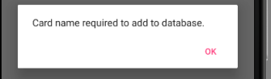

*Add delete button to home screen*

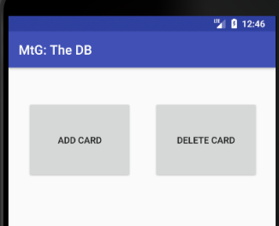

*User can search by name to bring up card information*

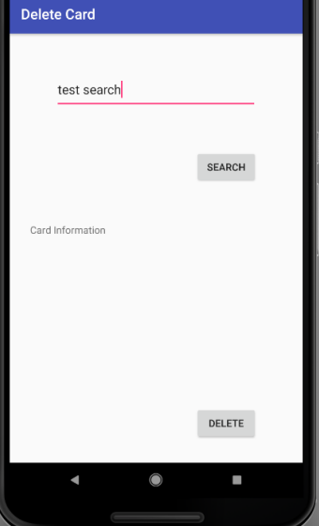

*If the card does not exist in the database an error message will display*

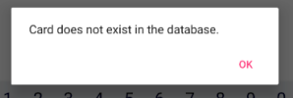

*If the card does exist information will populate on the screen:*

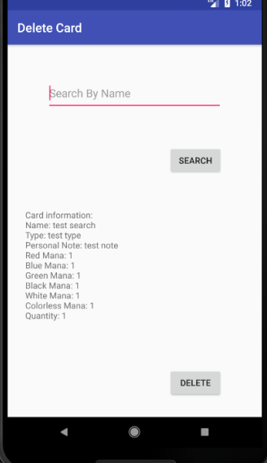

*User then selects delete and system deletes card from the database.*

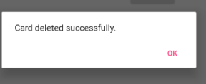

***Velocity*** *:*

Story 1 Complete : 15.

|  |  |  |  |
| --- | --- | --- | --- |
| **Story ID** | **Story / Task** | **Estimated**  **Hours** | **Actual**  **Hours** |
| S1 | Improve speed of app when accessing Room | 5 | 3 |
| S1 | Create error message if Card lacks Name | 2 | 6 |
| S1 | If card already exists in DB at to the quantity | 4 | 2 |
| S1 | Add cancel if the user finds error in entered info | 2 | 2 |
| S1 | Use query to code delete button | 2 | 8 |
|  |  |  |  |
|  | Total Hours: | 15 | 21 |
|  |  |  |  |
|  |  |  |  |
|  |  |  |  |
|  |  |  |  |

Sprint Review:

Story One is complete. I had to move tasks back to the product backlog due to other tasks proving to be much more time consuming than originally planned. Specifically, creating an error message if a card is entered without a name. There is a caveat in java that was not readily apparent. I spent a lot of time debugging why an error message would not populate inside of a loop. This is not a possible task in Java, so refactoring had to occur.

Rather than just having a simple delete button, I realized I wanted to have more of an interface surrounding the button so new functionality (as seen above) was added to accommodate a more user friendly card deletion experience. This increased time spent on delete functionality, but in the grand scheme creates a more user friendly experience.

Sprint Reflection:

During this sprint my primary goal was to research first and code later. I wanted my database access to be faster and safer (less crashes), I was able to both accomplish those goals, and understand why and where the crashes were likely to happen. I am quickly growing more confident and comfortable with the workings of the Room database, which will lead to much more efficient work throughout the process.

The large amount of design I added into the delete card process, shows that I need to spend more time fleshing out ideas and design plans. My original design, was complete, but it was not throughout enough. During the next sprint I need to create a more detailed plan and more UI mockups to avoid a large portion of implementation time being wrapped up in designing.

Sprint 3 Planning

|  |  |  |  |
| --- | --- | --- | --- |
| **Story ID** | **Story / Task** | **Estimated**  **Hours** | **Actual**  **Hours** |
| S0 | Flush out designs of future stories | 2 |  |
| S2 | Create search button on home screen | 1 |  |
| S2 | Implement search by name (allow wildcards) | 4 |  |
|  | Create new page for results | 2 |  |
| S2 | Implement browse by color | 4 |  |
|  | Create new page that allows user to scroll through all cards of a certain color | 1 |  |
| S2 | Implement Search by Note | 3 |  |
| S2 | Implement browse/search by type | 3 |  |
|  | Create new page that allows user to scroll through all cards of a certain type | 1 |  |
|  |  |  |  |
|  |  |  |  |

Sprint 3 Reflection

|  |  |  |  |
| --- | --- | --- | --- |
| **Story ID** | **Story / Task** | **Estimated**  **Hours** | **Actual**  **Hours** |
| S0 | Flush out designs of future stories | 2 | 2 |
| S2 | Create search button on home screen | 1 | 2 |
| S2 | Implement search by name (allow wildcards) | 4 | Moved back to backlog |
|  | Create new page for results | 2 | Moved to backlog |
| S2 | Implement browse by color | 4 | Moved to backlog |
|  | Create new page that allows user to scroll through all cards of a certain color | 1 | Moved to backlog |
| S2 | Implement Search by Note | 3 | Moved to backlog |
| S2 | Implement browse/search by type | 3 | Moved to backlog |
|  | Create new page that allows user to scroll through all cards of a certain type | 1 | Moved to backlog |
|  |  |  |  |
|  |  |  |  |
|  |  |  |  |

*Sprint 3 Review:*

Unfortunately poorly timed major IDE issues halted this sprint. I successfully added the search button to the main screen and implemented the text fields, check boxes, and a drop down menu to allow for browsing of the database. For a currently unknown reason the actual query to the database does not return any found cards. Any attempts to debug and find the reason were unsuccessful due to an IDE problem. My emulator has a tough time starting for some reason. Once it starts it cannot attach the debugger. This turned out to be a much more in depth issue than I could fix in the time I had before the end of sprint. At this point, I might have to do a full reinstall of Android Studio. This is also the reason for no screen shots of new features (I cannot access the emulator to get them).

*Sprint Reflection:*

Not having the time to fix my IDE in time is a very frustrating problem to have. Moving forward including time to solve any unexpected problems will be the forefront of planning. It will be difficult to plan for Sprint Four as I do not know how long it will take to fix whatever is wrong with my IDE. Also after reviewing all of my goals, for the project I will need to start having much heavier sprints. More features need to be added with enough time to also optimize the code. Time to put the pedal to the metal!

*Sprint 4 Planning:*

|  |  |  |  |
| --- | --- | --- | --- |
| **Story ID** | **Story / Task** | **Estimated**  **Hours** | **Actual**  **Hours** |
|  | Fix Android Studio | ?? |  |
|  |  |  |  |
| S2 | debug search by name (allow wildcards) | 2 |  |
|  | Create new page for results | 2 |  |
| S2 | debug browse by color | 2 |  |
|  | Create new page that allows user to scroll through all cards of a certain color | 1 |  |
| S2 | Debug Search by Note | 2 |  |
| S2 | Debug browse/search by type | 3 |  |
|  | Create new page that allows user to scroll through all cards of a certain type | 1 |  |
| S3 | Add Deck builder to home screen | 1 |  |
| S3 | Allow for user to build and save decks | 5 |  |
| S3 | Allow for user to use browse card to add to deck | 2 |  |
| S3 | Allow for to input new cards and save to both the deck and the main database | 3 |  |
| S3 | Allow for user to browse deck in app | 2 |  |
|  |  |  |  |

Sprint 4 Skipped

Sprint 5 Reflection

**Added Features:**

Added Browse and Deck Manager Features

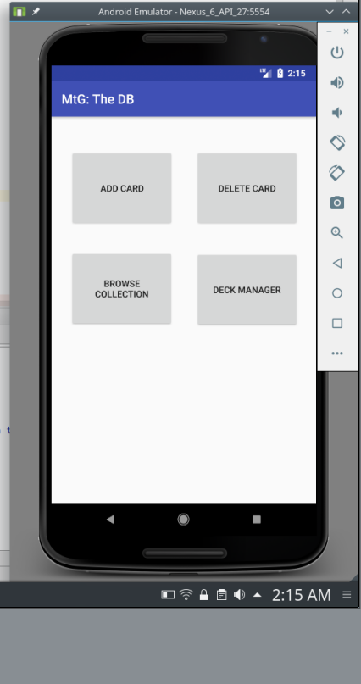

Browse Homepage: Browse By Color:

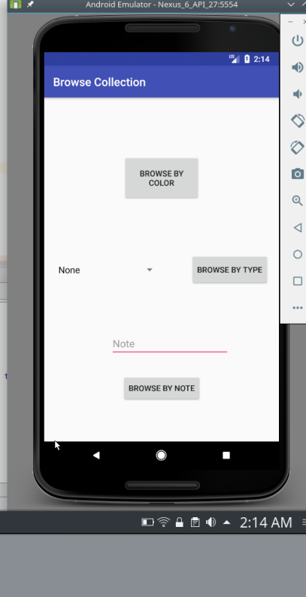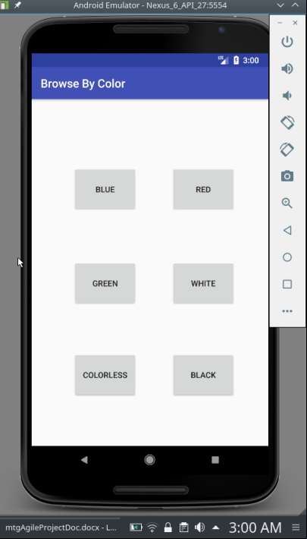

Browse by color results: Browse by Type Results:

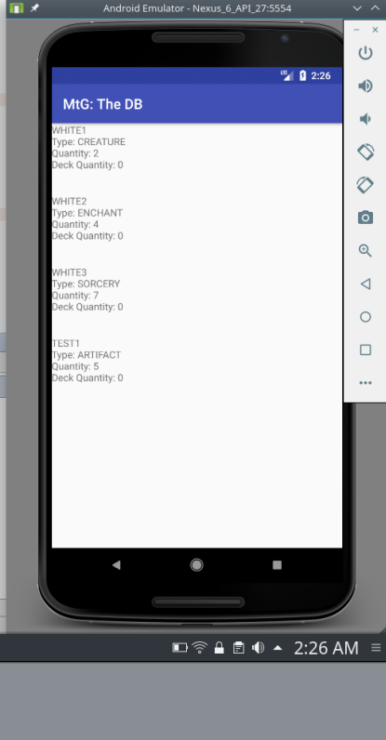

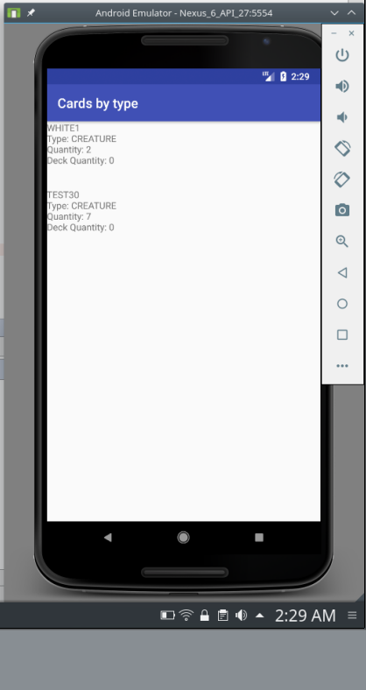

Browse by Note results: Deck Manager :

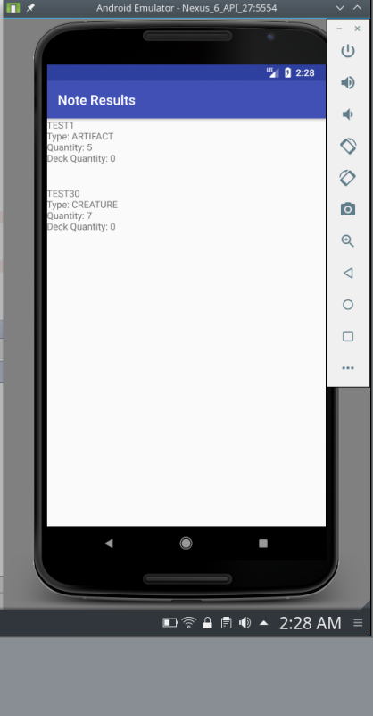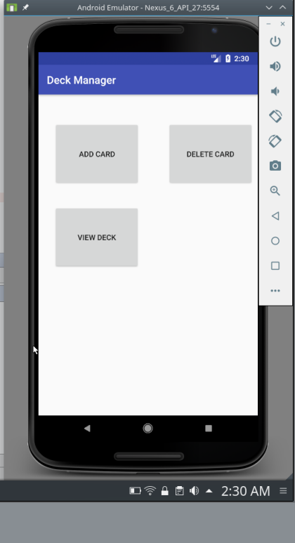

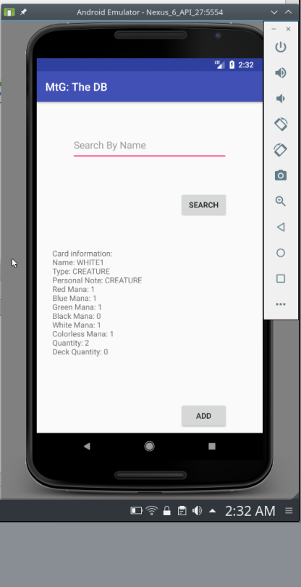Add to Deck: Add to deck success:

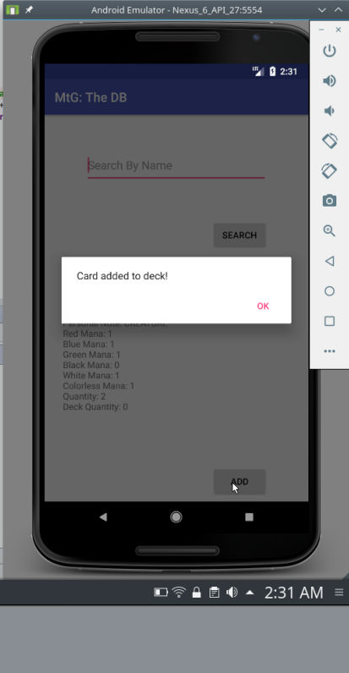

Delete from deck: Delete Success:

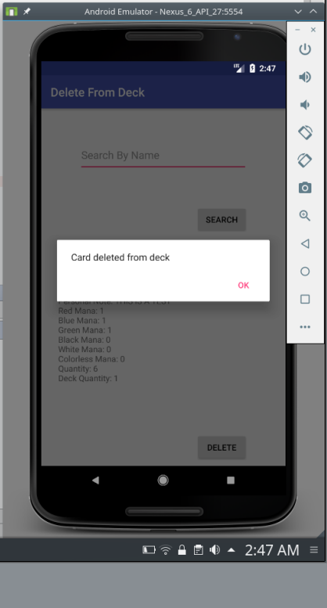

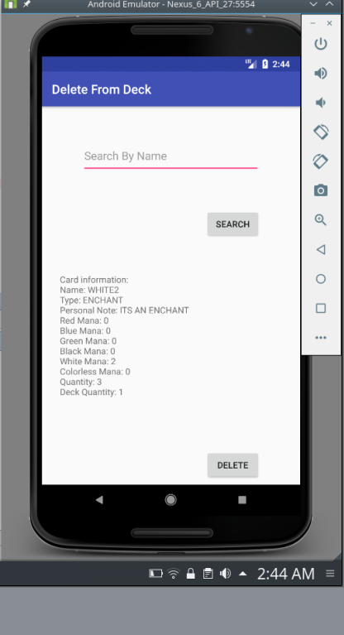

View Deck:

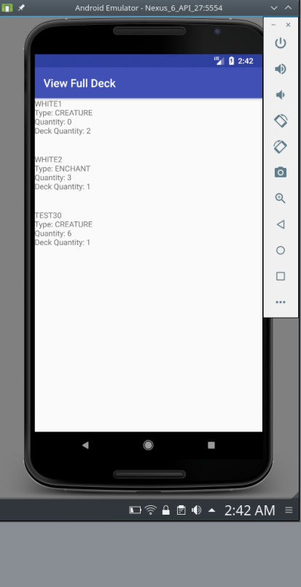

Sprint 5:

|  |  |  |  |
| --- | --- | --- | --- |
| **Story ID** | **Story / Task** | **Estimated**  **Hours** | **Actual**  **Hours** |
|  | Fix Android Studio | ?? | 20 |
|  |  |  |  |
| S2 | Completely Remake Browse Feature |  |  |
| S2 | Redesign browse page | 3 | 1 |
| S2 | debug browse by color | 2 | 7 |
|  | Create new page that allows user to scroll through all cards of a certain color | 1 | 5 |
| S2 | Debug Search by Note | 2 | 5 |
| S2 | Debug browse/search by type | 3 | 4 |
|  | Create new page that allows user to scroll through all cards of a certain type | 1 | 2 |
| S3 | Add Deck builder to home screen | 1 | 1 |
| S3 | Allow for user to build and save decks | 5 | 8 |
| S3 | Allow for user to use browse card to add to deck | 2 | 0 |
| S3 | Allow for to input new cards and save to both the deck and the main database | 3 | 0 |
| S3 | Allow for user to browse deck in app | 2 | 5 |
| S3 | Allow for user to delete cards from deck |  | 5 |
|  | General fixes and improvement |  | 3 |
| Total |  |  | 66 |

Sprint 5 Review:

Sprint 5 is realistically a combination of Sprint 4 and Sprint 5. Fixing Android Studio was tedious and time consuming. Once the IDE was back up and running I realized that the Browse feature needed more than debugging. It had to be scrapped and fully redesigned. The end result was a sleeker and more refined browse feature.

Allowing the user to create decks within the database proved to be much more difficult than I anticipated. Eventually, I decided to limit the user to be able to save cards to a single deck. Adding the functionality to save decks required me to remake my “cards” table with a new column “Deck Quantity”. Editing the existing table was a much more in depth process. At this stage of development, the simple answer was to create a new table “newCards”. For now, I intend to limit the application to only support one deck. In the future, beyond the scope of this project I plan to revisit multiple decks.

General fixes and improvements included a few different aspects of searching the database. Room database queries are case sensitive, so I opted to change all user input to upper case. To avoid an unnecessary use of assumptions I used a spinner to allow the user to input the type of the card. I added in try/catch blocks to avoid any exceptions, primarily around querying the database.

Sprint 5 Reflection:

Most of the major goals for the application are complete. The life counter should be very easy and quick to implement. I will do that during sprint 6. Otherwise, I do not plan to include my stretch goals. Instead I will use Sprint 6 to attempt to move around code and general code improvements. Adding more major functionality at this point will not be possible. I want to take the time to refactor my code make it more maintainable and completely test the application. So far, I have not had any issues that couldn’t be fixed, but I want to make sure there are not any edge cases.

Sprint 6 Planning:

|  |  |  |  |
| --- | --- | --- | --- |
| **Story ID** | **Story / Task** | **Estimated**  **Hours** | **Actual**  **Hours** |
| S5 | Implement Life Counter | 1 |  |
| S6 | Refactor and improve | 20 |  |
| S6 | Test | 15 |  |

Sprint 6 Reflection

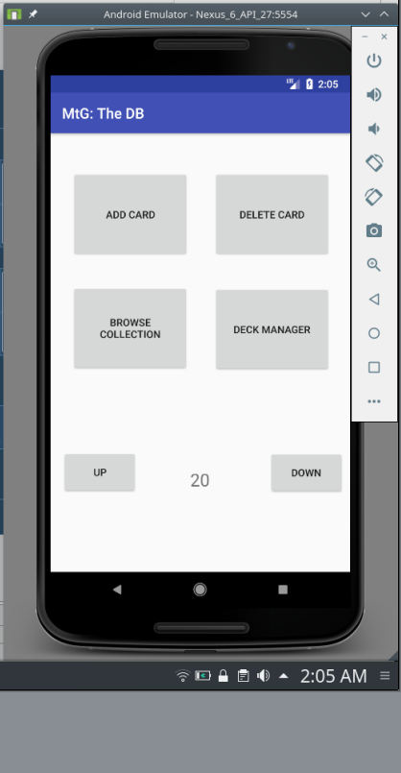

|  |  |  |  |
| --- | --- | --- | --- |
| **Story ID** | **Story / Task** | **Estimated**  **Hours** | **Actual**  **Hours** |
| S5 | Implement Life Counter | 1 | 1 |
| S6 | Refactor and improve | 20 | 15 |
| S6 | Test | 15 | 15 |
|  | Total |  | 31 |

Sprint 6 Review:

Sprint 6 had its up and downs. Testing went exceptionally well. I thoroughly tested all of the apps functionality and purposefully attempted to break it. I tried edge cases on data and weird UI elements. I could not get the system to bug in anyway. It handles edge cases via use of assumptions. The search functionality has room for improvement, but it does work as intended. Add and delete functionality work exactly as intended.

The Deck building functionality also works exactly as intended. Again there are future improvements in this area. The deck quantity and regular collection quantity interact as I wanted them too. I am very happy with the overall functionality of the entire project.

Refactoring did not go nearly as well as testing. The app does work as intended, but the code has a lot of room for improvement. Ideally, I wanted to move all logic and functionality into their own more generalized classes. I wanted to combine similar logic to minimize lines and increase re-usability. Clearly nothing stuck for the finished project.

Moving code would have been almost a complete rewrite of the application. In an attempt to move code and logic around, functionality broke. I spent time trying to fix it without moving the code back into the interface. This effort was basically fruitless. Coupling was greatly increased in my attempts to more generalize the code. Eventually, I made the decision to just move it back to the way it was.

Implementing the life counter was about as easy as I expected.

Sprint 6 Reflection

While I am happy with the functionality of the app, I wish my original design was more flushed out. Without having a clearly planned out classes and interfaces, every piece ended up being very static. Maintaining and improving this code will be more difficult than it needed to be. In the future, I will revisit this project and work to split the functionality away from the interface. In doing so, new functionality will be more easily added.